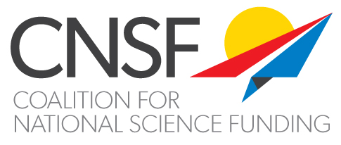

December 21, 2017

Coalition for National Science Funding Supports the Completion of Fiscal Year 2018 Appropriations for the National Science Foundation

The Coalition for National Science Funding (CNSF) -- a broad-based group of professional organizations, universities, businesses, and scientific societies that advocate for sustained, robust federal support for science – today issued the following statement on the Fiscal Year 2018 appropriation process.

“CNSF is calling on Congress to complete the Fiscal Year 2018 appropriations process and to pass a bipartisan budget agreement that increases the spending caps for discretionary programs in early January 2018. As a pillar of America’s scientific research enterprise, NSF-funded research is vital to the nation’s economy, national security, global competitiveness, and the preparation of the next generation of STEM workforce. For the U.S. to remain a global leader in science, technology, and innovation, we must continue to invest in NSF and the nation’s research enterprise. Thus, it is important for Congress to complete the Fiscal Year 2018 appropriations process and reach a budget agreement that raises the spending caps for discretionary programs.”

To learn more about CNSF, please visit <http://www.cnsf.us/>.